**Project Overview: AgriAdvisor**

**Transforming Agriculture with Technology**

**Introduction:**

In today's swiftly evolving agricultural landscape, well-informed decision-making forms the bedrock of successful farming. AgriAdvisor, our groundbreaking application, stands at the vanguard of reshaping the agricultural sector. It seamlessly integrates crop recommendations, precise fertilizer suggestions, and real-time disease detection within a user-friendly platform. With agriculture underpinning economies and communities worldwide, the significance of AgriAdvisor lies in its potential to empower farmers, growers, and agronomists.

It equips them with the knowledge and tools necessary to optimize crop yields, curtail resource wastage, and combat the constant specter of crop diseases. By bridging the chasm between technology and agriculture, AgriAdvisor promises to revolutionize farming practices, foster sustainable cultivation, and ensure food security for future generations.

**Objectives:**

The primary objectives of AgriAdvisor are:

* Augment agricultural productivity by providing farmers with precise and tailored crop recommendations based on their specific regions and conditions.
* Promote sustainable farming practices by offering meticulous fertilizer suggestions that minimize environmental impact and resource wastage.
* Shield crops against diseases through real-time detection and expert guidance, ultimately reducing crop losses and enhancing food security.

**Scope:**

AgriAdvisor offers a comprehensive range of services tailored to modern agriculture, including precise crop recommendations, fertilizer suggestions, and real-time disease detection. The application leverages advanced algorithms, agricultural data, and AI technology to provide users with invaluable insights and guidance. It's essential to note that while AgriAdvisor significantly enhances decision-making in agriculture, it should serve as a supplementary tool, and on-ground expertise remains invaluable in the agricultural industry.

**Data Sources:**

AgriAdvisor draws upon various data sources to fuel its functionalities:

Crop Recommendation Dataset: This dataset forms the backbone of crop recommendations, providing personalized guidance based on specific soil conditions, climate, and geographical regions.

Fertilizer Suggestion Dataset: In line with sustainability goals, a specialized dataset is curated to offer precise fertilizer recommendations, considering environmental factors to minimize ecological impact.

Plant Diseases Dataset: Real-time disease detection relies on a robust dataset of plant diseases, enabling swift identification and diagnosis for timely intervention.

**Methodologies:**

AgriAdvisor employs cutting-edge methodologies and data science techniques:

Plant Disease Classification using ResNet-9: Deep learning techniques accurately classify plant diseases from images, ensuring timely and accurate disease identification.

Support Vector Machine (SVM): SVM algorithms enhance the accuracy and reliability of recommendation systems, providing trustworthy guidance.

Random Forest: Ensemble learning techniques optimize decision-making processes, particularly in complex scenarios, by combining the outputs of multiple decision trees.

Gaussian Naïve Bayes: This probability-based algorithm provides insights into complex data patterns and anomalies, enhancing analysis precision.

XGBoost: XGBoost's gradient boosting capabilities further enhance model accuracy in predictive tasks.

**Conceptual diagram:**

**Technical Report**

Here, we'll dive into the technical aspects of the project. Let’s see the breakdown of the code with small code snippets for each step:

**Reading Data:**

The code reads two CSV files using Pandas and explore the first few rows of both DataFrames.

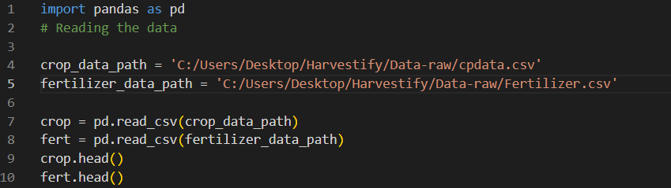

**Function for Changing Case:**

Define a function to standardize text by removing spaces and converting to lowercase. Standardizing Crop and Fertilizer Data by applying the change case function to the 'Crop' column in both DataFrames.

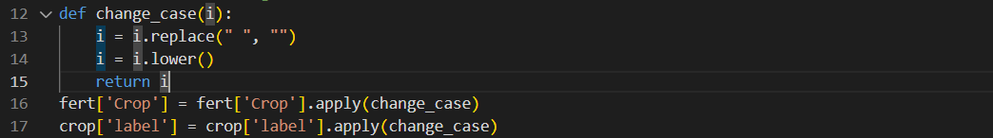

Remove the other names for the crop and replace them with the standard crop names.

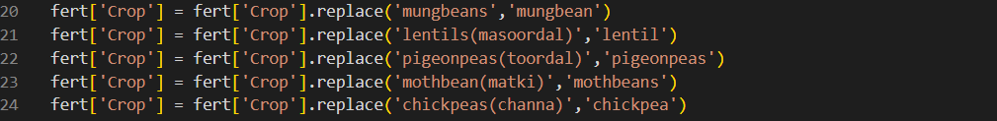

**Unique Crop Names:**

Extract unique crop names from the 'label' column in the crop DataFrame

Extract unique crop names from the 'Crop' column in the fert DataFrame:



**Matching Crop Names:**

Iterate through crop names from fertilizer data and check for matches:

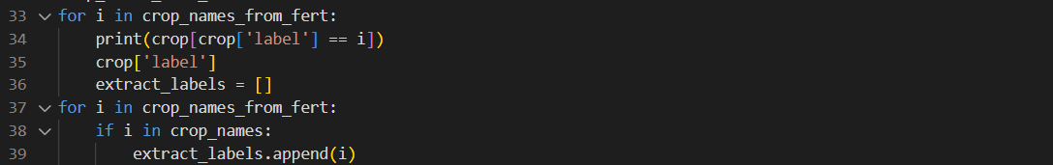

**Creating New DataFrames:**

Create empty DataFrames to store filtered data:  


**Appending Data:**

For each label in extract_labels, append data from the original DataFrames to the new DataFrames:



**Saving Data:**

Save the new DataFrames as CSV files:



**Feature Selection:**

Define the features (X) and the target variable (Y).



**Model Training and Evaluation:**

Train multiple machine learning models, including Decision Tree, Naive Bayes, Support Vector Machine (SVM), Logistic Regression, Random Forest, and XGBoost.

Evaluate the accuracy of each model on a test set and store the results.

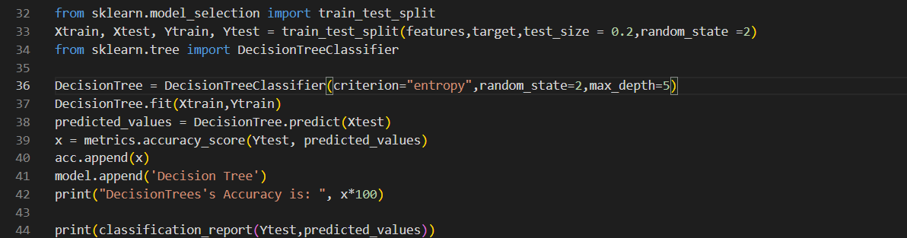

**Cross-Validation Score:**

Perform cross-validation to assess the models' performance.

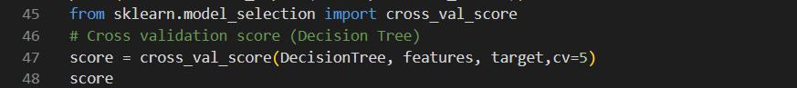

**Saving Trained Models:**

Save the trained models using Pickle for later use.

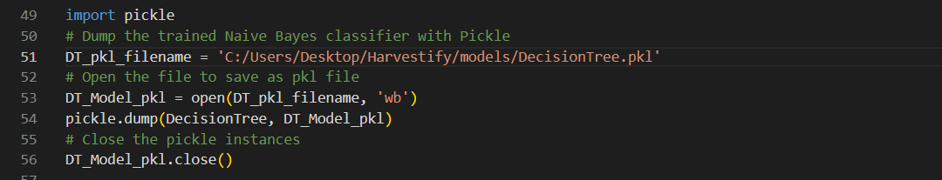

**Accuracy Comparison and Visualization:**

Compare the accuracy of different models and visualize the results

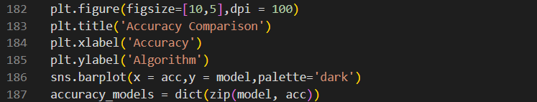

**Result:**

This visualization shows the accuracy comparison of the different algorithms.

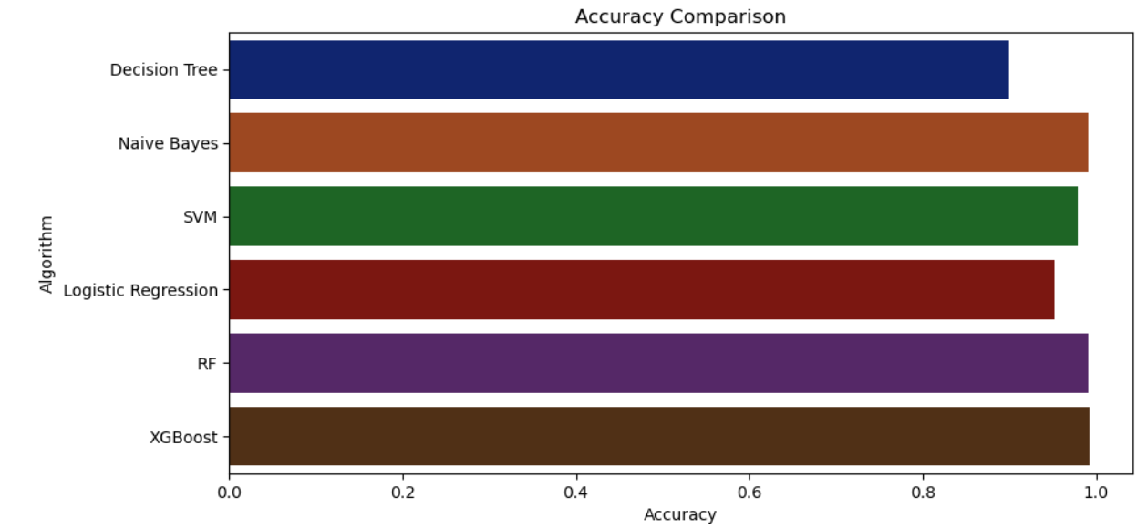

Frontend Design:

This is the home page of the website for the AgriAdvisor.

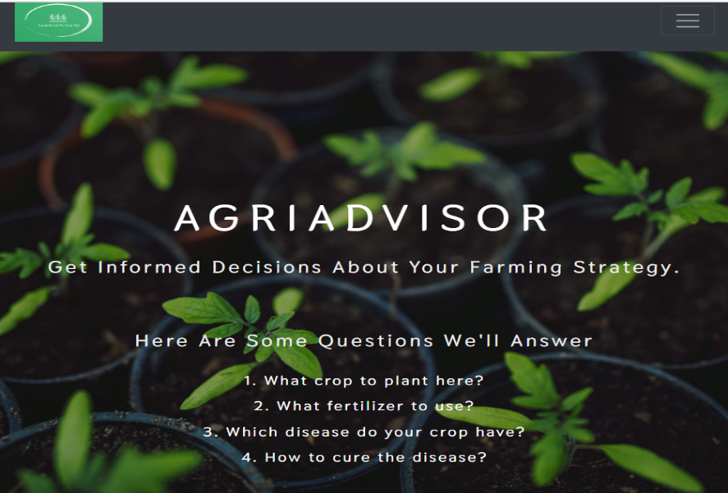

In the home page we have the description of the services we provide as well.

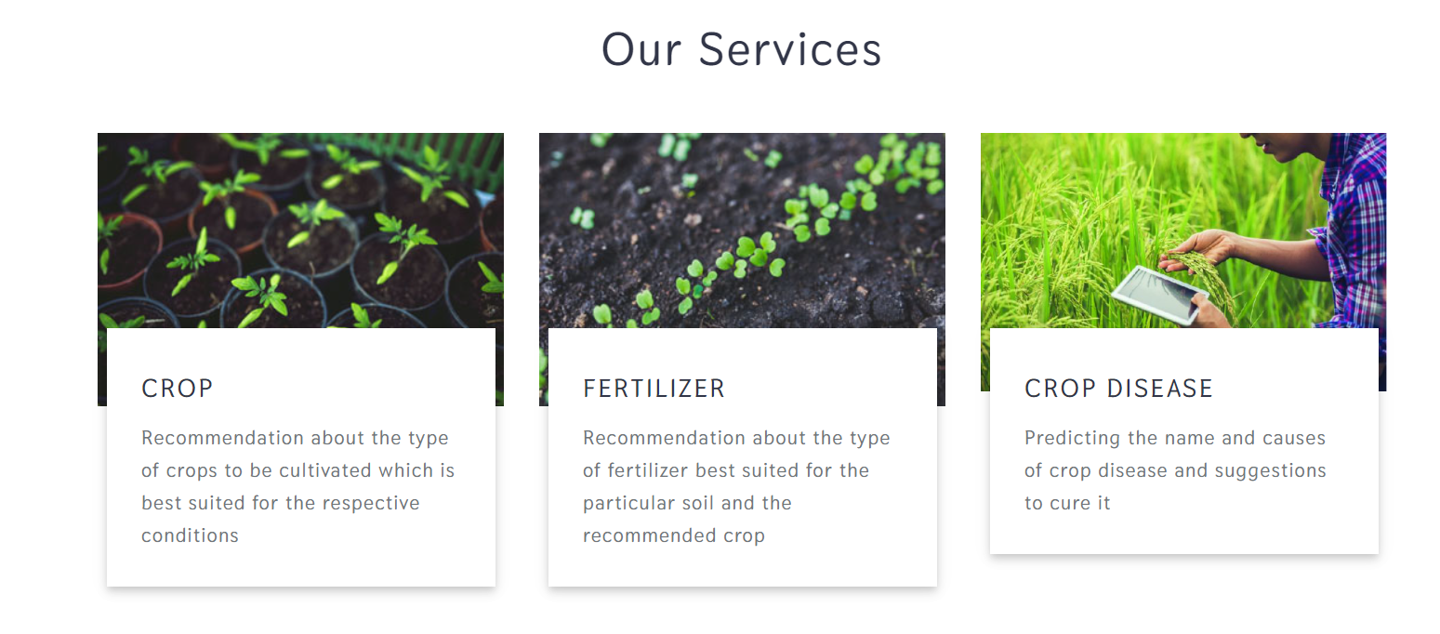

This pages below are for the crop recommendation, fertilizer recommendation and disease prediction for the crop based on different factor like soil type, geographical location, growth stage and images etc.

